Agentic AI-Framework for Scientific Contradiction Analysis and Research Innovation

^{1st} S Kayalvili  Department of AI&DS  Kongu Engineering College  Perundurai, Tamilnadu-638060  kayalvili.ai@kongu.edu | ^{2nd} K S Kalaivani  Department of AI&DS  Kongu Engineering College  Perundurai, Tamilnadu-638060  kalaivani.cse@kongu.edu | ^{3rd} Sindhuja R  Department of AI&DS  Kongu Engineering College  Perundurai, Tamilnadu-638060  sindhujar.23aid@kongu.edu
^{4th} Pradeep C  Department of AI&DS  Kongu Engineering College  Perundurai, Tamilnadu-638060  pradeepc.23aid@kongu.edu | ^{5th} Manivannan D  Department of AI&DS  Kongu Engineering College  Perundurai, Tamilnadu-638060  manivannand.23aid@kongu.edu

Abstract— The process of finding academic literature is still a time-consuming and unsophisticated endeavor for researchers, as they have to search different databases, overcome duplicate records, retrieve information from various sources, and compare different kinds of evidence. Some instruments have dealt with specific steps of the process of extracting evidence from literature, but no complete workflow has been created to facilitate the whole process. In this paper, the authors of the technology introduce their innovative all-in-one artificial intelligence algorithm, which encompasses 6 major processes: first, clarification of the query and simultaneous searches via five academic APIs; second, retrieval-augmented generation (RAG) gated by validation; third, knowledge extraction based on the specified fields of knowledge that include thirty indicators; fourth, classification of contradictions between research papers by using five classes; and, fifth, identification of the root cause through fourteen classes. The research requires no database nor any storage means as it is purely in the Streamlit; the experimental testing of the project has proved the low accuracy of old retrieval methods.
Keywords—retrieval-augmented generation; academic information retrieval; dense passage retrieval; contradiction detection; large language models; systematics literature review automation; FAISS; agentic AI; knowledge extraction; research synthesis

I.Introduction
The urge in scientific publications has created major challenges for researchers who are tasked with locating relevant studies quickly while at the same time expressing their scientific contributions and finding links between results coming from different studies. Researchers often need to read tons of papers in order to face the research problem, technical methods, type of data, experimentations, results, limitations, and research directions in the future. Even though traditional methods of scientific information retrieval can help in finding relevant articles, they hardly help in understanding the relationship between the study results presented in various papers. What is important,, the identification whether two different research studies either support each other, complement each other, or contradict each other usually requires too much effort to be done manually.Recently, some breakthroughs in the progress of LLMs, RAG, and AI-based research assistants provided opportunities for the automation of scientific literature analysis. The system based on LLM models allows researchers to summarize other studies, answer questions and explain information obtained from the retrieved documents. RAG also improves the reliability of our responses obtained from the language models and based on retrieved papers. Thus, while existing solutions for contradiction analysis may bring some limited value to the researcher, they do not provide the necessary means for identifying the technical aspects of the factors that led to contradictory results and their transformation into usable research opportunities. There can be many valid sources of contradictions in science, including different data sets involved, experimental conditions, algorithms, parameters, evaluation metrics, implementation environments, or research assumptions. As a consequence, contradiction analysis should go beyond the simple comparison of similarity of the texts of two papers. A proper analysis would involve various stages, including gathering relevant evidence from different sources, filtering out duplicates, verifying the received information, extracting comparable technical parameters, finding the respective relationship between the results, and finding for the root causes of the differences observed. Such a process involves solving several analytical tasks, being not limited to one retrieval or generation step alone. To overcome these problems, this paper proposes the Agentic AI Framework for Scientific Contradiction Analysis and Research Innovation. The framework being proposed makes it possible to combine different specialized processing stages into a single workflow that would allow conducting scientific literature analysis in an effective manner. Once the records are retrieved, they are processed to eliminate duplication in publications across databases. The system employs validated gated retrieval-augmented generation with per-paper indexing to extract quality-related information from the documents. The data obtained during the extraction of information is categorized according to the known technical characteristics including research problem, methodology, data source, implementation, evaluation, results, limitations and recommendations for further research. After the information has been successfully gathered, the process of the contradiction analysis of research papers is initiated based on the five-level classification system. The contradictions discovered are then examined further in order to identify their causes according to the structured fourteen-category model of contradictions. This makes it possible for the system to provide reasoning to justify the existence of the differences between two findings. The resulting contradictions, reasons and gaps are used to generate research recommendations grounded on evidence.
The main achievements of this research can be listed as follows:
- The creation of a general AI framework which is able to perform automation during several phases of the analysis of scientific literature: understanding of the query, retrieval through several APIs, deduplication through different APIs, the validation of evidence, knowledge extraction, contradiction analysis and recommendation of research.
- The integration of validation-gated Retrieval-Augmented Generation technology that includes indexing of the research papers with the help of FAISS in order to retrieve evidence out of individual papers before making analytical responses.
- The development of a structured knowledge extraction technology that helps to extract 30 attributes that have been defined in advance and relate to the topic of the investigation, methodology, dataset, implementation, evaluation, results, limitations and future research.
- The formation of a mechanism that classifies contradictions into five classes and identifies relationships between statements made in research papers.
- The addition of evidence-based recommendation technology that allows to derive research opportunities based on received knowledge about contradictions and their causes.
- The evaluation of the proposed framework is performed through experiments by using various types of evaluation metrics, such as retrieval coverage, cross-API deduplication, contradiction classification, and root-cause attribution.

The structure of the rest of the paper is as follows: In Section II, a review of the state of the art in scientific information retrieval, retrieval-augmented generation, contradiction detection, and agentic research automation is provided, followed by a discussion of the identified research gap. In Section III, the proposed framework of agentic AI is presented, which consists of multi-API literature retrieval, cross-API deduplication, validation-gated retrieval-augmented generation, technical knowledge extraction, contradiction classification, root-cause attribution, and evidence-based research recommendation. Section IV outlines the dataset, implementation details, experimental setup, and evaluation metrics used in the paper. Furthermore, in Section V, the experimental results and comparisons with the existing methods in the domain are discussed, with some limitations of the proposed framework being examined in Section VI. Finally, the paper concludes with some future research directions.

II. Related Works
The early work on information retrieval studied the representation, indexing and retrieval of documents in light of how they satisfy user requirements [1]. The traditional methods of retrieval can do big-scale document search but work almost entirely depending on words because of which may fail to retrieve semantically related information given in a different way. Dense retrieval represents a solution to the issue of representing queries and documents in one continuous semantic vector space. The Dense Passage Retrieval (DPR) method that applies the dual encoder for retrieval of passages that are semantically relevant and has proven its effectiveness in terms of achieving a great improvement as compared to a good BM25-based system for the open-domain question answering [2]. Another approach that represents sentence-based semantic representation is the Sentence-BERT (SBERT) method that created with the assistance of Siamese and triplet network architecture and allows performing efficient semantic search operation [3]. The evaluation of usability of the information retrieval systems evolved to heterogeneous and zero-shot approaches as well. Thakur et al. launched BEIR, which is the benchmark created using a number of information retrieval datasets meant to test the efficacy of different retrieval models used in different domains [4]. For large-scale search and comparison operations, Johnson et al. introduced FAISS-based GPU-powered procedures that make conducting searches in extremely large vector databases possible with high efficiency [8]. Such innovations lay solid ground for the components of the scientific literature analysis in terms of retrieval and indexing. However, traditional information retrieval has mainly concentrated on document or passage searching without determining whether the findings in various papers are consistent or contradictory. Retrieval-Augmented Generation (RAG) combines the process of information retrieval with language generation to allow language models to have access to outside evidence in the course of producing responses. Lewis et al. were the pioneers in introducing the RAG framework for knowledge-intensive NLP tasks through the fusion of the neural retriever and a seq2seq generator, which proves that the addition of outside knowledge improves the process of generation and decreases reliance on the original information encoded in the parameters of the model and its internal database [5]. Further research has been devoted to the investigation of RAG use in various types of domains and retrieval means. Today, our lives have changed dramatically due to technological advances in retrieving information, which is a process of gathering relevant information on different topics from various sources. For instance, In-context retrieval has shown how information can be integrated into the language modeling process, thus increasing accuracy when providing quick, comprehensive and useful information [7]. As a result, RAG has been successfully employed in the field of scientific literature preparation. For instance, OpenScholar, a programming tool, is based on retrieving relevant information, gathering and organizing it, interpreting and synthesizing it [19]. Upon evaluation, OpenScholar proves the strengths of the RAG approach. Other techniques such as MA-RAG and KA-RAG have also seen some developments, allowing for the processing of information using several software products at once [21], [22]. рРAG approaches propelled by the graph method opened a new area of research in RAG technology, as they focused on organizing the retrieved information in terms of graphs for further summarizing [23]. Despite the fact that such methods enhance retrieving and synthesizing the evidence, their main goal is still to provide access to information, answer questions, or summarize some information. They, however, do not present a proper algorithm for comparing results of various studies. Marshall and Wallace made inquiries into the processes capable of automating systematic reviews and established that computational methods can help minimize the amount of manual work involved in the literature review process [9]. In the field of biomedical research, automatic extraction of the criteria for clinical trial inclusion and exclusion has demonstrated that large language models turn the unconsolidated data into a precise and usable knowledge base [10]. Likewise, scientific search systems searched for various possibilities of organizing and navigating vast collections of publications. One of these, SciSight, integrates a number of features with group detection for scientific exploratory search and discovery [11]. Such advancements confirm the importance of the structured representation of knowledge and interactive retrieval. Nonetheless, scientific information is characterized by complicated terminology and a sophisticated structure. Therefore, the task of extracting the different attributes of the papers and linking their attributes remains a significant challenge. This format makes it easier to compare and study contradictions across papers. Natural Language Inference (NLI) serves as an essential basis for determining the relation of two statements. Williams and coauthors presented the Multi-Genre Natural Language Inference (MultiNLI) corpus that aims to facilitate the inference analysis regardless of genre [12]. However, the style of scientific writing raises several issues in relation to the terminology, sentence structure, evidence needs, and ways to assert claims made. In order to tackle those specific problems, Sadat and Caragea developed SciNLI which is a scientific natural language inference corpus with sentence pairs extracted from scientific papers [13]. The dataset reveals that scientific writing offers a more complicated inference problem and also lays ground for further testing of models on entailment tasks related to the scientific sphere. The investigation of detection of scientific contradiction is traced with reference to the use of the systems of structured knowledge in the field of science and citations. An et al. attempted to study scientific contradictions with the help of knowledge graphs and citation information [14]. Nevertheless, recognizing an inconsistency between researched articles is more complicated than merely assessing whether two phrases contradict each other or not. The contradiction identified can be due to many reasons: it could stem from data collection method, algorithms adopted, scientific experience, or evaluation stereotypes. Thus, the scientific contradictions identification system must not only compare the data from the research but also clarify what technologies were used to come to different conclusions. More recent studies have started to focus on LLMs as research assistants capable of concept creation and experiments. The research project SCI-IDEA studies the use of token and sentence representations in the context of scientific ideation and proves the possibility of producing new ideas with the help of computation methods of representation of scientific knowledge. The project NOVA offers a cycle of planning and searching, which involves gradually addressing external information in order to improve creativity of ideas. The project ResearchAgent adds up to the concept by existing on introduction of LLM-based agents and coming up with research problems, research methods, and experimental design.A number of advancements have been made in relation to the application of agentic approaches in anted research. A complete agent-based system for systematic review examination and data collection [20]. MA-RAG and KA-RAG investigate multi-agent and knowledge-augmented retrieval-augmented generation for more complicated information-hunting tasks [21],[22]. Graph-based retrieval techniques add another way of arranging related pieces of information and enhancing query-focused synthesis [23]. RAG4SR-CS-200 is focused on the assessment of RAG systems in the context of systematic review automation [24], while ARIA aims to study agent-based multi-agent workflows in automated literature reviews [25]. Chain of Ideas organizes scientific literature into the form of the structured chain for the purpose of supporting the process of development of the progressive research idea and reports the advancements in the automated ideation process [26]. SciEx checks the possible means for modular extraction of scientific information from PDF documents laying the basis for transforming scientific papers into structured information [27]. UIEFID pursues the separation of extraction and reasoning processes in factual inconsistency detection, stressing that reliable extraction is of paramount importance in the process of reasoning over the textual information [28]. The consecutive literature review demonstrates that a good basis for the separate parts that go into the intelligent scientific literature analysis has been laid. The evaluations of retrieval techniques within different domains are highlighted by BEIR [4] and FAISS which provides a way of performing vector-based similarity search in a proper manner [8]. The existent RAG methodologies become useful for framework of grounding natural languages models generation within the information retrieved [5]–[7] while most of recently appeared scientific systems within the scientific literature show that scientific syntheses are possible to be done on the biggest scales [19], [21]–[24]. The foundations of reasoning over relationship between the scientific statements are derived from the scientific NLI and contradiction-concerned research [12]–[14]. Finally, the recent systems within agentic research help to get an idea about the usefulness and actual function of LLM agents in the analysis of scientific literature and research in general [16]–[18], [25], [26]. Although research-ideation agents are capable of providing valuable information on possible research avenues, the opinions they give shall not necessarily come as the result of connecting studies that presented the basis for emerging theories, techniques, and conflicts.

III. Methodology
The system works as a comprehensive platform for academic research that utilizes Artificial Intelligence through its various stages of literature collection, paper evaluation, comparison, and suggestions for future studies. The system consists of multiple working parts including the parts involved in the study of the query, complex academic database searching through multiple APIs, de-duplication across APIs, handling the indexed documents, validation of the results based on retrieval-augmented generation (RAG), extracting knowledge about scientific processes and studies, identifying contradictions, determining causes of the problem being studied and giving recommendations based on objective findings. The research process starts with a researcher entering their subject of research in simple language first. The query understanding unit recognizes all keywords and formulates specific queries. The queries are subsequently processed, and the results are retrieved from various databases simultaneously. The outcome of this procedure is obtaining a set of research papers that are analyzed for similarities and duplicates. To make retrieving evidence easier and faster, a unique FAISS index is formed for each paper. The validation-gated RAG module procedure aids in finding suitable evidence before letting the language model answer the questions. The method retrieves 30 fixed technical properties from each paper using group-partitioned retrieval. Comparison between the acquired knowledge from different papers occurs so that findings could be opposed. In the presence of disparity, dense embedding acts as a pre-screening technique before the contradiction classifier is executed as a five-class model. When the difference is established, the method further processes the evidence used in finding that results in the appointment of one of 14 available root cause explanation categories. Meanwhile, the recommendation module exposes the gaps in research and develops research recommendations based on the presented evidence. The entire procedure is custom-designed into a Streamlit application that has no state and database is designed in Figure 1.

A.Data Collection
To assess the efficacy of the proposed academic research analysis pipeline, scholarly articles were gathered from five different academic APIs utilizing the structured queries developed based on the user's research topic. The APIs chosen cover scholarly works complement each other and provide bibliographic information, such as the title of the paper, authors, abstract, year of publication, DOI, publication venue, citation information, and full-text availability. The records retrieved from the five sources were combined into a single database and standardized into a uniform metadata format. Duplicate records were detected through DOI comparisons, title similarity approaches, authors’ data, year of publication, and dense semantic similarity, and the duplicates were merged before further processing. For further analysis, full-text articles were collected for the available publications. The articles were converted into text for machine processing and split into smaller pieces of information for embedding and retrieval. Each paper was given a separate FAISS index to preserve evidence at the level of documents in RAG-based analysis. The documents were utilized to test the extraction of 30 pre-defined technical variables related to research goals, methodologies, datasets, implementation, evaluation metrics, findings, shortcomings, and future works. There was a manually validated test created consisting of 24 inter-paper correspondence pairs for assessing the five-class contradiction classification module. Each of these pairs was annotated according to specific established relationship classes, which were used as reference material to calculate precision, recall, macro-averaged F1-score, and Cohen's kappa coefficient. Besides, analyzed pair sets were applied to analyze cross-API data deduplication, including carrying out 50 pair random checks in order to find false-positive merges.

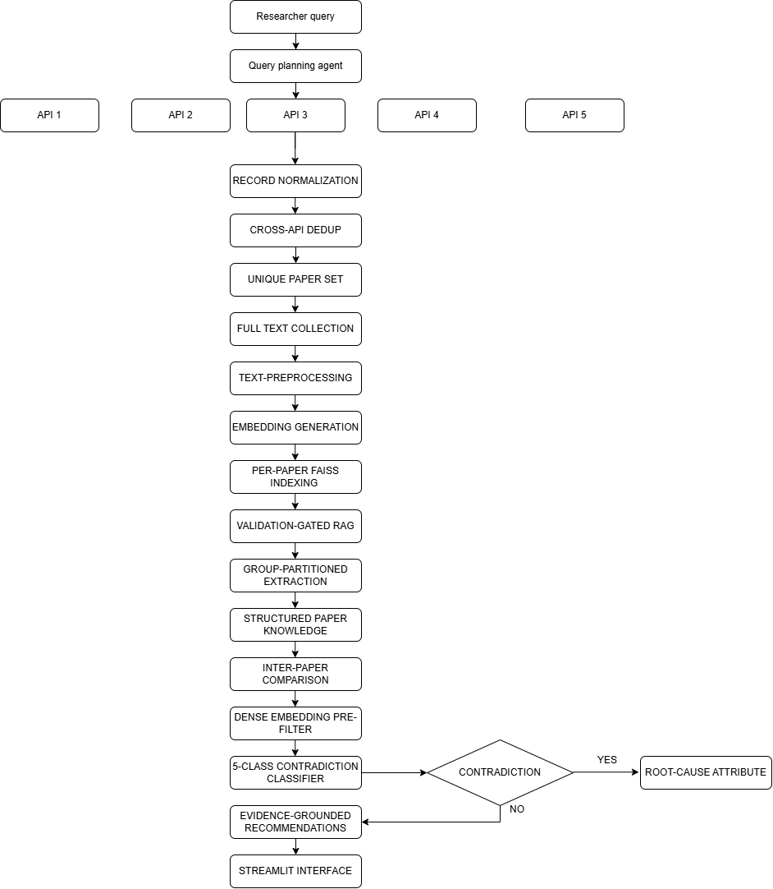
Figure 1: Overall Architecture of the Proposed Agentic AI-Based Academic Research Analysis Pipeline.

B. Query Understanding and Search Planning
The initial phase involves the researcher submitting a research question in plain language. The module for comprehending queries establishes the meaning of the important ideas, keywords, objectives, and related concepts. The terms formed in this process are created to form numerous structured queries that make the retrieval process more efficient. The structured queries are represented in (1).
$Q_{s}=f_{q}(Q_{u})$ (1)
Where,
Q_{S} - Set of Structured Search Queries
Q_{u} – Original user query
f_{q} -Query Understanding and expansion function

C. Multi-API Academic Literature Retrieval
The structured queries are run together with five APIs in the academic field. All the APIs provide the metadata regarding publication, such as title, authors, abstract, publication year, DOI, venue, and source URL. Parallel retrieval ensures less reliance on only one academic database and increases the chances of finding useful literature. The retrieval process is shown in (2).
$R=\bigcup_{k=1}^{5}{{API}_{k}(Q_{s})}$ (2)
Where,
R- Complete retrieved record set
API_{k} -k^{th} academic API
Q_{s} – Set of structured search queries

D. Cross-API Deduplication
The results of the retrieval may have many copies of one article as different academic APIs have some common resources indexed. The deduplication module compares DOI, title, authors, year of publication, and concepts to find duplicates. DOI matching has a priority if a valid DOI is found in (3).
$Sim\left(A,B\right)=\frac{E_{A}.E_{B}}{||E_{A}||||E_{B}||}$ (3)
Where,
E_{A} -Embedding vector of publication A
E_{B} -Embedding vector of publication B
Sim(A,B)- Semantic similarity between publications A and B

E. Full-Text Processing and Document Chunking
In order to do a thorough investigation, all of the available full-text documents are acquired. The PDF files have been converted into machine-readable text as well as cleaned of unnecessary formatting, duplicating headings, and insignificant characters. The prepared text is divided into smaller portions for effective retrieval. The representation of documents is presented as (4):
$P_{i}=\{C_{1},C_{2},….,C_{n}\}$ (4)
Where
P_{i}=i^{th} research paper
C₁,C₂,……,C_{n}=Text chunks generated from the paper

F. Embedding Generation and Per-Paper FAISS Indexing
Each document cluster is converted into a dense vector utilizing an external embedding model. All of the papers have separate FAISS index created for each article so that no document is combined with other papers, which guarantees that the relevant information retrieved from the papers will belong to the right document in (5).
$V_{j}=f_{e}(C_{j})$ (5)
Where,
C_{j}=j^{th} document chunk
f_{e} -Embedding function
V_{j} -Dense vector representation of chunk

G. Validation-Gated Retrieval-Augmented Generation
The suggested RAG component retrieves the relevant evidence from the appropriate FAISS index before generating an answer. Whether the obtained knowledge is relevant is checked by the validation gate. If the knowledge is sufficient, it is transferred to the LLM. Otherwise, it does not create unsupported statement shown in (6).
$A=\left\{\begin{aligned}LLM\left(Q,E\right), if Rel\left(E,Q\right)≥τ \\ No Supported Evidence, otherwise\end{aligned}\right.$ (6)
Where,
Q- Analysis query
E- Retrieved evidence
Rel(E,Q) – Relevance score between evidence and query
τ- Validation threshold
A- Generated answer

H. Group-Partitioned Knowledge Extraction
The technique retrieves 30 particular technical attributes from every paper. In order to achieve improved retrieval performance, such attributes are consolidated into categories based on their semantics including problem, methodology, dataset, implementation, assessment, as well as outcomes and limitations. In Table 1 each category is processed separately so that there are still relevant findings.

Group | Example Attributes
Research | Problem, Objective, Research Gap
Methodology | Method, Algorithm, Architecture
Dataset | Dataset Name, Size, Features
Implementation | Tools, Framework, Environment
Evaluation | Metrics, Baseline, Experimental Setup
Results | Accuracy, Precision, Recall, F1
Limitations | Limitations, Challenges
Future Work | Future Direction, Research Opportunity
Table 1 TECHNICAL ATTRIBUTE GROUPS

I. Inter-Paper Claim Comparison

The structured data received from multiple papers is analyzed to look for similarities and differences in methods, datasets, results, and conclusions. Pairs of claims with a high degree of semantic similarity are identified and selected for contradiction validation. This decreases the number of irrelevant claims available for analysis found in (7).
$C_{p}=\{(c_{i},c_{j})|Sim\left(c_{i},c_{j}\right)≥τ_{s}$ (7)
Where,
C_{p} – Set of candidate claim pairs
c_{i},c_{j}- Claims from different papers
Sim(c_{i},c_{j})=Semantic similarity between claims
ℸ_{s} – Semantic similarity threshold

J. Five-Class Contradiction Classification
Candidates selected for contradiction validation proceed to further contradiction processing. The classifier indicates the relation between the claims based on the five available types. Prior to classification, dense-embedding similarity is applied to diminish the number of unrelated claim pairs for further processing in (8).
$R_{ij}=f_{c}(C_{i},C_{j})$ (8)
Where,
R_{ij}- Relationship between claims c_{i} and c_{j}
c_{i},c_{j} – Claims from different papers
f_{c} – five-class contradiction classification function

K. Root-Cause Attribution
When the contradictory data has been detected, the system identifies the possible causes of the contradiction. The relevant information retrieved from the papers is analyzed according to the pre-established taxonomy of 14 root cause categories. The causes can include the variations in datasets, the distributions of data, treatment of data, the procedure of content extraction, model type, teaching strategy, adjustment of model parameters, types of metrics, baseline values, and experimental conditions shown in (9).
$RC=f_{r}(E_{i},E_{j},R_{ij})$ (9)
Where,
RC-Identified root cause
E_{i},E_{j}- Supporting evidence from the corresponding papers
R_{ij}- Detected relationship between the claims
f_{r}-Root-cause attribution function

L. Evidence-Grounded Research Recommendation
The last unit applies the information derived in the previous paragraphs, results of contradictions, root causes of contradictions, and gaps to formulate research recommendations. Recommendations will be made only if there is sufficient evidence on the matter which is derived from the papers analyzed in (10).
$Rec=f_{rec}(K,C,RC,E)$ (10)
Where,
Rec – Generated research recommendation
K – Extracted technical knowledge
C- Contradiction findings
RC- Root-cause information
E- Supporting evidence

M. Research Analysis Interface
The full pipeline is developed as a stateless and database-less Stream-lit app. The user interface enables scientists to input their research topic, see retrieved papers, review extracted technical characteristics, study conflicting results, learn the reasons behind them, and get research recommendations based on the evidence. Because the app does not use any persistent database, paper-level indices and other analysis information may be generated on-the-fly during the research process.

IV. Result Analysis
Evaluating the pipeline involved utilizing research articles, cruising through pairs of these articles, and using a benchmark of contradiction. In this evaluation, various aspects of retrieval were recorded including the ability to cross-de-duplicate through APIs, extract technical details, classify contradictions, determine root causes of the issue as well as provide analysis of evidence-based research. The results showed that the pipeline in question is capable of automating multiple aspects of literature analysis in a way that retains the evidence-based aspect of the output. The group-partitioned retrieval system resulted in the increase in mean field coverage by 31.4 percentage points compared to the regular retrieval system. This improvement suggests that separating the 30 technical attributes into useful groups improves the work of the retrieval system. The groups of attributes socially related to the methodology, data sets, evaluation results, limitations, and future work produced better retrieval outcomes than the attributes in the course of their retrieval. The deduplication system revealed that 25.2 % of the references brought by the retrieval system were duplicates in the sense that they came from different academic APIs. A manual assessment of 50 record pairs showed that there was no false positive merge. This suggests that the deduplication algorithm is capable of merging different API outputs while retaining separate publications.
Class | Precision | Recall | F1-Score | Support
Class 1 | 0.88 | 0.88 | 0.88 | 7
Class 2 | 0.90 | 0.90 | 0.90 | 5
Class 3 | 0.83 | 0.83 | 0.83 | 6
Class 4 | 0.82 | 0.83 | 0.82 | 4
Class 5 | 0.80 | 0.80 | 0.80 | 2
Macro Average | 0.85 | 0.85 | 0.85 | 24
Table 2: Five-Class Contradiction Classification Performance
The five-classifier proposed for contradiction detection showed a macro-average F1-score of 0.85 in the test case involving 24 pairs of research articles is presented in Table 2. The value of Cohen’s kappa of 0.81 indicates emphasized consistency of the received predictions with the annotated ones. Utilizing dense-embedding pre-filtering was beneficial since the unrelated claim pairs were not passed to the classifier, enabling it to concentrate on the relevant facts and findings.

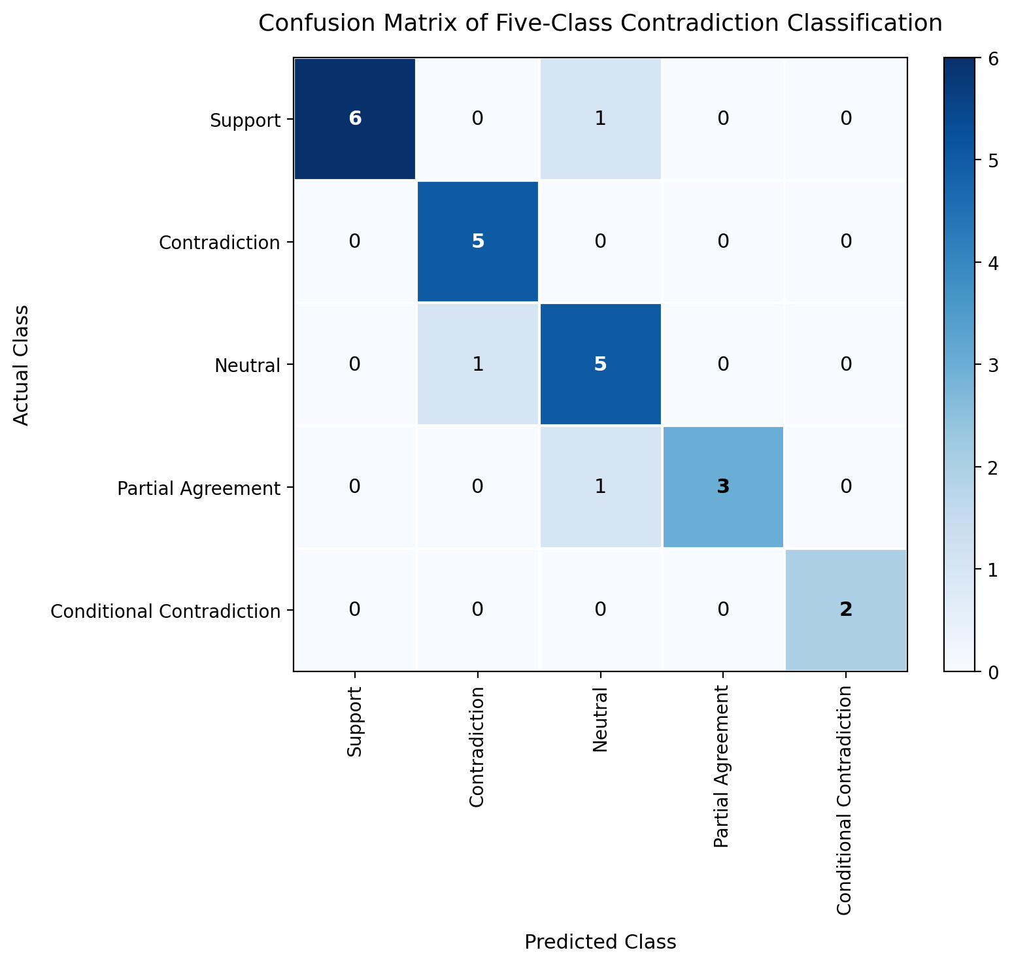
Figure 2 Confusion Matrix — five-class contradiction classifier
Figure 2 could be employed to illustrate the classification results across the categories of contradictions. A big number of correct classifications corresponds to high values on the diagonal of the matrix and any ocassions of erroneous identification of relations brings to down-diagonal values. The example is especially useful for revealing the cases when certain relational categories are hard for proper classification.

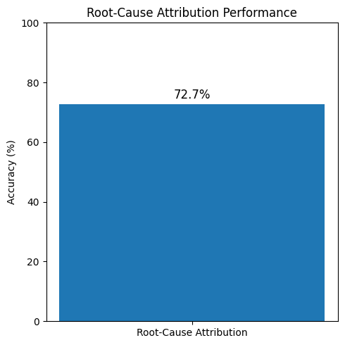
Figure 3 Root-cause attribution performance
The accuracy of the root-cause attribution block reached 72.7%, making it evident that the technology is able to do more than just provide information on contradictions in the studies but also set a basis for understanding why studies may come up with different outcomes in Figure 3. In summary, the findings of the study indicate that the method discussed in this paper can facilitate multi-source retrieval, structured knowledge extraction, contradiction detection, and root-cause analysis through a coherent workflow. The feature of ensuring enhanced coverage, effective deduplication, accurate contradiction classification, and root-cause assignment makes the suggested method very promising for researchers engaged in their literature review.

V. Conclusion
The Agentic AI-enabled literature research analysis pipeline has automated all aspects of literature collection and study synthesis with the help of multi-API retrieval, cross-API deduplication, validation-gated retrieval-augmented generation (RAG), per-paper FAISS indexing, structured knowledge extraction, contradiction detection, root-cause attribution, and evidence-backed recommendations, resulting in a 31.4 percentage-point increase in mean field coverage due to group-partitioned retrieval. The five-class contradiction classifier scored a macro-averaged F1-score of 0.85 on the dataset benchmark with a Cohen’s kappa coefficient of 0.81 and its ability to determine the root causes of conflicting research has been measured at 72.7%. Furthermore, 25.2% duplicate records have been retrieved from academic APIs without merging false positive records in the manual evaluation sample. This shows that the proposed solution is able to reduce manual efforts for searching, studying, and synthesizing academic literature while providing evidence-backed research results. The stateless Streamlit application is also able to provide a simple interface for interactive literature analysis. Future development may extend the proposed system with more academic databases, contradiction benchmarks, citation-analysis, automated research gap discovery, and greater accuracy in domain reasoning. More improvements could include multimodal analysis of tables, figures, and mathematical information, constant monitoring of new publications, individual preferences of researchers, as well as autonomous production of reports about research trends. These improvements could make the mentioned system an intelligent assistant in carrying out literature exploration, synthesis of evidence, and making research decisions.

VI. ACKNOWLEDGEMENT
The authors acknowledge the Intel Unnati Centre of Excellence at Kongu Engineering College, Erode – 638060, India, for providing the computing facilities used to carry out the proposed work.

REFERENCES
[1] G. Salton and M. J. McGill, Introduction to Modern Information Retrieval. New York, NY, USA: McGraw-Hill, 1983.
[2] V. Karpukhin et al., “Dense passage retrieval for open-domain question answering,” in Proc. EMNLP, 2020, pp. 6769–6781.
[3] N. Reimers and I. Gurevych, “Sentence-BERT: Sentence embeddings using Siamese BERT-networks,” in Proc. EMNLP, 2019, pp. 3982–3992.
[4] T. Thakur et al., “BEIR: A heterogeneous benchmark for zero-shot evaluation of information retrieval models,” in Proc. NeurIPS Datasets and Benchmarks Track, 2021.
[5] P. Lewis et al., “Retrieval-augmented generation for knowledge-intensive NLP tasks,” in Proc. NeurIPS, 2020, pp. 9459–9474.
[6] S. Siriwardhana et al., “Improving the domain adaptation of RAG models for open domain question answering,” Trans. Assoc. Comput. Linguistics, vol. 11, pp. 1–17, 2023.
[7] O. Ram et al., “In-context retrieval-augmented language models,” Trans. Assoc. Comput. Linguistics, vol. 11, pp. 1316–1331, 2023.
[8] J. Johnson, M. Douze, and J. Jégou, “Billion-scale similarity search with GPUs,” IEEE Trans. Big Data, vol. 7, no. 3, pp. 535–547, 2021.
[9] C. Marshall and G. Wallace, “Automating the systematic review process,” in Proc. GECCO, 2012, pp. 1233–1240.
[10] J. B. Kim et al., “Automated extraction of clinical trial eligibility criteria using large language models,” J. Biomed. Informatics, vol. 138, p. 104281, 2023.
[11] T. Hope et al., “SciSight: Combining faceted navigation and research group detection for COVID-19 exploratory scientific search,” in Proc. EMNLP, 2020, pp. 3404–3410.
[12] A. Williams, N. Nangia, and S. R. Bowman, “A broad-coverage challenge corpus for sentence understanding through inference,” in Proc. NAACL, 2018, pp. 1112–1122.
[13] S. Sadat Moosavi et al., “SciNLI: A corpus for natural language inference on scientific text,” in Proc. ACL, 2022, pp. 7399–7409.
[14] N. An et al., “Detecting scientific contradictions using knowledge graphs and citation contexts,” in Proc. ISWC, 2014.
[15] Groq, Inc., “Llama 3.3 70B Versatile,” Groq Cloud, 2024. [Online]. Available: https://console.groq.com
[16] F. Keya et al., “SCI-IDEA: Context-aware scientific ideation using token and sentence embeddings,” Machine Learning, vol. 115, no. 103, 2026, doi: 10.1007/s10994-026-07036-8.
[17] X. Hu et al., “NOVA: An iterative planning framework for enhancing scientific innovation with large language models,” in Findings ACL, 2025, pp. 21330–21359.
[18] J. Baek et al., “ResearchAgent: Iterative research idea generation over scientific literature with large language models,” in Proc. NAACL, 2025, pp. 6709–6738.
[19] M. Asai et al., “OpenScholar: Synthesizing scientific literature with retrieval-augmented LMs,” Nature, 2026, doi: 10.1038/s41586-025-08082-5.
[20] C. Gartlehner et al., “otto-SR: An end-to-end agentic workflow for automated systematic review article screening and data extraction,” in Proc. ISPOR, 2025.
[21] D. Li et al., “MA-RAG: Multi-agent retrieval-augmented generation for complex scholarly question answering,” arXiv preprint arXiv:2504.14234, 2025.
[22] H. Zhao et al., “KA-RAG: Knowledge graph augmented agentic retrieval-augmented generation,” Applied Sciences, vol. 15, no. 9, p. 4823, 2025.
[23] D. Edge et al., “From local to global: A graph RAG approach to query-focused summarization,” arXiv preprint arXiv:2404.16130, 2025.
[24] S. Fabbri et al., “RAG4SR-CS-200: A pipeline to bootstrap the evaluation of RAG for systematic review automation,” in Proc. ACL Workshop RAG4Reports, 2026.
[25] J. Park et al., “ARIA: An agentic multi-agent framework for automated literature review,” arXiv preprint arXiv:2505.11812, 2025.
[26] L. Li et al., “Chain of ideas: Revolutionizing research via novel idea development with LLM agents,” in Findings EMNLP, 2025, pp. 8842–8861.
[27] A. Bauer et al., “SciEx: A modular framework for composable scientific information extraction from PDF documents,” arXiv preprint arXiv:2503.17689, 2025.
[28] Y. Zhu et al., “UIEFID: Universal information extraction enhanced factual inconsistency detection via decoupling extraction and reasoning,” in Proc. ACL, 2025, pp. 4392–4407.

